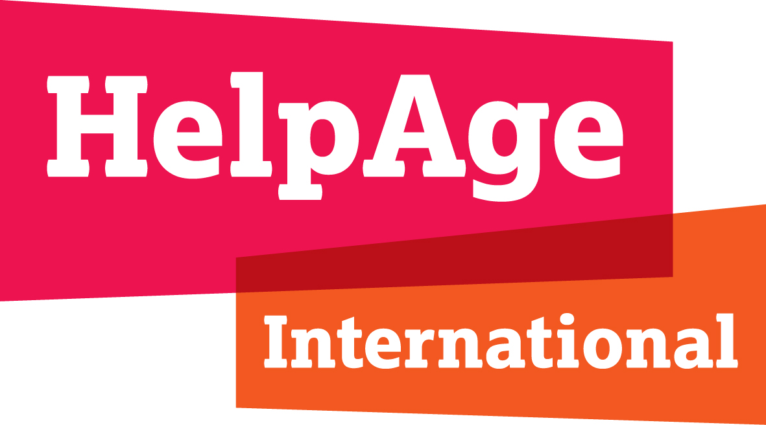

|  |  |
| --- | --- |
|  | **The impact of COVID-19 on older persons**  Vietnam analytical brief  June 2020 |

|  |
| --- |
| Highlights  * Vietnam has recorded no deaths from COVID-19 and only 327 cases (as of end-May), of which 28 (or 8.6 per cent) were older people. Among 16 serious cases, 25 per cent were older people. * Thanks to the country’s experience in responding to outbreaks of infectious diseases like SARS, MERS and measles, for COVID-19 the country successfully "relied on relatively cost-effective solutions: quick strategic testing, aggressive contact tracing, effective public communication campaigns and swift development of testing kits." * From 1 April, the country carried out strict social isolation for 15 days national-wide, followed by new distancing instructions by location, depending on risk. On 24 April, the Prime Minister issued a directive to safely restart the economy. The outbreak of COVID-19 is expected to have a significant impact on Vietnam's economic development this year.[1] * The government responded quickly with a number of relief measures, including the unprecedented 62 trillion VND (2.66 billion USD) package for six affected groups. It is estimated that at least 3.5 million of Vietnam’s 11.4 million older people will benefit. * Interviews with key informants show that older people’s ongoing health care needs were often not addressed due to social distancing. From the supply side, health services were provided only for urgent cases. From the demand side, older people did not dare to go out to see their doctor because they were worried about being infected, especially those having chronic diseases. * Social care services were either disrupted (if provided by care centres) or limited (if by community) during social distancing. As a result, older people relied only on family carers. |
| Changes in general context The most affected businesses are airlines, tourism, textiles, education, commerce and handicrafts.[2] In first quarter 2020, GDP growth is estimated at 3.82 per cent (General Statistics Office) and worse is expected in later quarters. Revised 2020 growth forecasts of between 2.7 (IMF) and 4.8 per cent (World Bank) compare to 6.5-6.8 per cent predicted before the pandemic by Ministry of Finance.[3] The downturn is expected to temporarily increase the poverty rate in the first half of 2020.[4] |
| Changes in national COVID-19 situation On 23 January 2020, the first two cases in Vietnam were reported. There have been four stages of the pandemic: (1) 23 January to 25 February: 16 cases, all from China or with direct contact with those coming back from China; (2) 6-19 March: After 13 consecutive days with no new cases, on March 6, 2020, Vietnam announced new cases, all imported. (3) 20 March to 21 April: Community spread. Strict social distancing was applied from 1-15 April national-wide and until 23 April in some high-risk cities/provinces. (4) 22 April to now: The COVID-19 spread is under controlfor now. The country has applied new measures to keep the country safe while its economy restarts.  Thanks to the country’s experience in responding to outbreaks of infectious diseases like SARS, MERS and measles, in the case of COVID-19 the country "relied on relatively cost-effective solutions: quick strategic testing, aggressive contact tracing, effective public communication campaigns and swift development of testing kits."[5] |

# Key changes in situation of older persons

## Health and care

Although older people are more at risk from COVID-19, the percentage of older people infected with the virus in Vietnam is relatively low. Among 327 COVID-19 cases (both Vietnamese citizens and foreigners), only 28 cases have been among older people (or 8.6 per cent). If counting only Vietnamese citizens, the percentage is 5.75 per cent. Among 4.89 per cent of cases that were serious (in hospital longer than two weeks or received critical treatment), 25 per cent were older people.[6]

Interviews with key informantsshows that older people’s ongoing health care needs were often not addressed due to social distancing. From the supply side, health services provided only for urgent cases. From the demand side, older people did not dare to go out to see their doctor for check-ups and treatment because they were worried about being infected, especially those having chronic diseases. Alternative health services (such as telemedicine/online consultation) were introduced but only at the later stage (an app was launched on 18th April) and only a few health facilities have managed to implement these so far. Not all older people can access these online services, either because they do not have access to the internet and smartphones or do not know about the services. Health check-up services at home are provided only in some big cities such as Ho Chi Minh City and Hanoi. Payment is also an issue as home check-ups are not covered by health insurance, except for those aged 80+ or older people having a very serious health problem.

According to interviews of key informants, community care services, if any, were either disrupted (if provided by care centres) or limited (if by community members) during the social distancing. As a result, older people in need relied on family carers, who typically have very little or no training on care. The situation has been worse for those living alone. Interviews with Ministry of Labour, Invalids and Social Affairs (MOLISA) and Ministry of Health (MOH) representatives show that residential care in government-managed centres was not disrupted, except when serious health problems were beyond the capacity of the centre's health workers to address. In those cases, it was hard to refer patients to higher levels because of social distancing.

## A close up of a logo Description automatically generatedIncome security­

Interviews with key informants confirmed that older people having no contributory pension and/or working in the informal sector face severe income challenges. In Vietnam 25 per cent of older people live in poor households.[7] Just 42 per cent of older people have some form of guaranteed income through the pension system: 27 per cent with a contributory pension or social insurance (Vietnam Social Security, 2018) and 15 per cent with a social pension. In addition, the monthly social pension is just 270,000 VND ($11.5), equivalent to only 40 per cent of the rural poverty line and 30 per cent of the urban poverty line.

More than 60 per cent of older people aged 60-69 still work. But the vast majority of age 60+ workers in Vietnam (81 per cent)[8] are informal workers. Informal workers are the hardest hit group during COVID-19 and form the majority of the workforce in 4 out of 5 hardest hit sectors.[9]

A large percentage of older persons rely on children’s support (32 per cent).[10] With more than 86 per cent of businesses negatively impacted by COVID-19[11] and a grey economic picture in general, support from children to older parents is predicted to decline.

## A picture containing drawing Description automatically generated Social issues

Interviews with key informants suggest that COVID-19 increased social isolation among older people, although the negative impacts may not have been as serious as in some countries because the social distancing period was not that long in Vietnam. Older people could not meet their friends or go out. In addition, many of them, especially in remote areas, do not use smartphones or have access to the internet, and thus have limited options to connect with family and friends. The situation was worse for older people living alone or as a couple.

# Responses

***Government:*** Overall, the Vietnamese government has acted promptly and strongly to contain the spread of the virus. Although Vietnam is a middle income country with high exposure to the source of the pandemic (China), the country has been praised internationally for its success.[12] The government carried out many COVID-19 prevention and control measures, with implications for older people.

Along with these measures, the government also implemented a large relief programme to support those affected by COVID-19, including older people. The 62 trillion VND ($2.66 billion) relief package targeted six groups of individuals and businesses hit by the pandemic including: (1) the poor and near-poor (entitled to cash benefit of VND250,000 or $10.22 per month/person), existing social protection beneficiaries including social pension beneficiaries (social pension beneficiaries are those aged 80+ having no contributory or social insurance benefits, who were entitled to VND500,000 or $21.45 per month), and revolutionary contributors (entitled to VND500,000 or $21.45 per month); (2) employees with no contract but lost their work; (3) employees with temporarily suspended contracts; (4) employees with terminated contracts but not eligible for unemployment benefits; (5) temporarily suspended household businesses; and 6) enterprises with no revenue or funds to pay salaries, which can get zero-interest loans to pay an additional half a month’s salary to their employees.

Of these six programmes, it is estimated that at least 3.5 million of Vietnam’s 11.4 million older people will benefit for three months, especially from the first two schemes. That is, 1.8 million older people have a pension; nearly all of the 1.4 million revolutionary contributors are older people; and about 25 per cent of the beneficiaries from the 1.4 million poor households are older people, not counting those from near-poor households or informal workers. (A person can receive only one benefit.) A main challenge in transferring the cash to these groups is targeting. It is a time-consuming and complicated task to pinpoint older people who are not in the existing beneficiary lists, particularly informal workers. Other than the social security relief package, the government also advanced a two-month supply of medicines and developed at-home or distance health services for older people. Because time is rushed, not all policies and technical documents came with detailed implementation guidelines or allocated budget at the beginning, limiting the coverage.

The government has done well with a massive communication campaign. Vietnam achieved 89 per cent trust among respondents in COVID-19 media coverage, according to a survey by YouGov[13]. On the other hand, there is still limited *age-friendly* messaging for older people – for example, non-technical materials with graphics. MOH has developed two key guidance notes: “COVID-19 prevention for older people” and “Non communicable disease and health management guideline for primary health care during COVID-19”.

***Non-government bodies:***Non-government bodies have developed many policy recommendations and guidelines. In addition, they have also been active in providing tangible support to communities. The role of mass organization such as Vietnam Women's Union (VWU), Vietnam Association of the Elderly (VAE), and Vietnam Red Cross (VNRC) are important to reach the most isolated and disadvantaged. VAE, as the organisation of older people in Vietnam, quickly issued official calls for guiding older people in how to prevent COVID-19 infection and raising matters of concerns to local authorities. VAE also joined HelpAge to provide cash support to 150 disadvantaged older people in two provinces. Vietnam Red Cross’s initiative"Humanitarian Market” was implemented in 59 provinces, providing necessities for 110,000 poor people as of end of May (VND 35 billion or $1.5 million),[14] with people older than 65 or frequently ill among the target groups.

### Apart from HelpAge, there is a lack of age disaggregated data in almost all reports.

***Private sector:***Private sector companies have contributed substantial financial or in-kind support.[15] Some examples are: Samsung Vietnam donated VND10 billion ($426,617), 15 banks donated VND135 billion ($5.7 million)[16], CapitaLand donated 40,000 COVID-19 tests valued at $1 million.[17]

***Broader public response:***The Vietnamese community at home and abroad has actively donated to a fund launched by Vietnam Father Land Front on 19 March. As of 15 April, nearly VND1.6 trillion (nearly $69 million) was raised.[18] The fund is used to support the fight against COVID-19 and address socio-economic damage. Another initiative is the rice ATM, which has been automatically dispensing free rice to people badly affected by the COVID-19 pandemic.

|  |
| --- |
| A picture containing person, fence, outdoor, sitting  Description automatically generatedCase study Ms. Ninh Thi Hong, 63 years old, from Dong Da district, Hanoi city, who owns a small breakfast food stall.  “I hope that the disease ends soon so that I can come back to work. I do not want to be dependent.”  COVID-19 has seriously affected the life of people like Ms. Hong, an older self-employed worker. Even before COVID-19 was recognized as a pandemic, her business slowed down. Ms. Hong ran her food stall from early morning until noon and got a profit of 200,000 VND each day (8 USD). That amount was not much, but enough for her family of three to get by. Ms. Hong has three children, but only the youngest, a sophomore student at a university, still lives at home with her and her husband.  Since the lockdown on 1 April, Ms. Hong stayed at home the entire time. She could not make any money for living necessities such as electricity, water and food. Fortunately, she received 10 kg of rice from the local commune government and 2 kg from Vietnam Red Cross. The couple still have to pay everything for their youngest son, but they do not have any pension. They cannot pay his tuition fee, so the university has instructed them to apply for a support scheme to help reduce the fee. The family struggle because they rely mostly on Ms. Hong’s street food business.  Source: [https://ione.net/tin-tuc/video/nguoi-ngheo-trai-qua-nhung-ngay-khong-lam-an-gi-duoc-nhu-the-nao-4089065.html (23](https://ione.net/tin-tuc/video/nguoi-ngheo-trai-qua-nhung-ngay-khong-lam-an-gi-duoc-nhu-the-nao-4089065.html%20(23) March 2020) |
|  |

#### Endnotes

1. . [COVID-19 Impact Assessment: Analysis of the Potential Impacts of COVID-19 on Vietnamese Economy](https://www.pwc.com/vn/en/publications/vietnam-publications/economy-covid19.html). PWC Vietnam, 2020.
2. . According to Vietnam Chamber of Commerce and Industry
3. . [Kinh tế Việt Nam năm 2019 và triển vọng 2020 (Vietnam's economy in 2019 and prospects for 2020).](https://www.mof.gov.vn/webcenter/portal/tttc/r/o/nctd/nctd_chitiet?dDocName=MOFUCM171761&dID=179313&_afrLoop=66854836323857486#!%40%40%3FdID%3D179313%26_afrLoop%3D66854836323857486%26dDocName%3DMOFUCM171761%26_adf.ctrl-state%3Dqszd6ip0u_4) Ministry of Finance, 31 January 2020.
4. . [WB điều chỉnh triển vọng tăng trưởng GDP Việt Nam năm 2020 xuống còn 4,9% (World Bank adjusted the growth of Vietnam's GDP in 2020 to 4.9%)](https://forbesvietnam.com.vn/tin-cap-nhat/wb-dieu-chinh-trien-vong-tang-truong-gdp-viet-nam-nam-2020-xuong-con-49-10027.html). Forbes Vietnam, 31 March 2020.
5. . [Here are four ways Vietnam has managed to control COVID-19](https://www.gavi.org/vaccineswork/here-are-four-ways-vietnam-has-managed-control-covid-19). Gavi, 25 May 2020.
6. . COVID-19 epidemic statistics update. Ministry of Health, 28 May 2020.
7. . 2017 report to VNCA annual report. GSO, 2017.
8. . Report on Informal Employment in Vietnam. International Labour Organization, 2016.
9. . [COVID-19 and the labour market in Viet Nam](https://www.ilo.org/wcmsp5/groups/public/---asia/---ro-bangkok/---ilo-hanoi/documents/briefingnote/wcms_742134.pdf). ILO, 21 April 2020.
10. . Viet Nam Ageing Survey (VNAS) 2011: Key Findings, Giang, Long. 2012.
11. . [86% doanh nghiệp chịu tác động tiêu cực bởi Covid-19 (86% of businesses are negatively affected by Covid-19)](https://thoibaokinhdoanh.vn/viet-nam/86-doanh-nghiep-chiu-tac-dong-tieu-cuc-boi-covid-19-1068174.html). Thoi Bao Kinh Doanh, 8 May 2020.
12. . [Foreign media praise Vietnam's response to COVID-19 pandemic](https://en.nhandan.org.vn/society/health/item/8593802-foreign-media-praise-vietnam-s-response-to-covid-19-pandemic.html). Nhandan, 21 April 2020.
13. . [VN has highest trust in COVID-19 media coverage: YouGov poll](https://vietnamnews.vn/society/717090/vn-has-highest-trust-in-covid-19-media-coverage-yougov-poll.html). Viet Nam News, 22 May 2020.
14. . Vietnam Red Cross Society (VNRC) report on Humanitarian Month.
15. . [Vietnamese communities abroad join hands in COVID-19 fight](https://english.vov.vn/society/vietnamese-communities-abroad-join-hands-in-covid19-fight-412170.vov). Vov, 4 May 2020.
16. . [Samsung Vietnam donates VND10 billion to COVID-19 prevention](http://bizhub.vn/corporate-news/samsung-vietnam-donates-vnd10-billion-to-covid-19-prevention_314596.html). Bizhub, 7 April 2020.
17. . [CapitaLand donates 40,000 tests valued at US$1 million for COVID-19 prevention](https://www.capitaland.com/international/en/about-capitaland/newsroom/news-releases/vietnam/2020/april/capitaland-donates-40-000-tests-valued-at-us-1-million-for-covid-19-prevention.html#menu-lang-main). CapitaLand7 April 2020.
18. . [Vietnamese communities abroad join hands in COVID-19 fight](https://english.vov.vn/society/vietnamese-communities-abroad-join-hands-in-covid19-fight-412170.vov). Vov, 4 May 2020.

    Contact information

    Tran Bich Thuy, Country Director, thuytb@helpagevn.org

    HelpAge International, Vietnam Country Office